Used Book Sharing System

Software Architecture Document

Version 1.2

Revision History

|  |  |  |  |
| --- | --- | --- | --- |
| **Date** | **Version** | **Description** | **Author** |
| 21/11/2019 | 1.0 | Initial document | Bui Quang Thang |
| 29/11/2019 | 1.1 | Add Logical View | Dang Duc Trung & Tran Thuan Thanh |
| 30/11/2019 | 1.2 | Edit Use-case model: add new features | Bui Quang Thang |
|  |  |  |  |

Table of Contents

1. Introduction 4

1.1 Purpose 4

1.2 Scope 4

1.3 Definitions, Acronyms and Abbreviations 4

1.4 References 4

2. Architectural Goals and Constraints 4

3. Use-Case Model 4

4. Logical View 6

4.1 Component: Favorite Book List View 6

4.2 Component: Search View 6

4.3 Component: Comment & Rate View 7

4.4 Component: Profile View 7

4.5 Component: Book Service 8

4.6 Component: Account Service 8

4.7 Component: Search Service 9

4.8 Component: Book Demonstrate Blog View 9

4.9 Component: Blog Service 10

4.10 Component: Contact Service 10

4.11 Component: Book Description View 10

4.12 Component: Chat View 11

4.13 Component: Authentication View 11

4.14 Component: Support User View 11

4.15 Component: Upload Book View 11

4.16 Component:Manage Book View 12

4.17 Component: Support Service 12

4.18 Component: Favorite Book List Service 13

4.19 Component: Contact Data Access 13

4.20 Component: Book Library Data Access 13

4.21 Component: Account Data Access 13

4.22 Component: Blog Data Access 13

4.23 Component: Manage User View 14

5. Deployment 14

6. Implementation View 14

**Software Architecture Document**

# Introduction

## Purpose

This document provides a comprehensive architectural overview of the Used Book Sharing System, using a number of different architectural views to depict different aspects of the system. It is intended to capture and convey the significant architectural decisions which have been made on the system.

## Scope

## This Software Architecture Document applies to the Used Book Sharing System which will be developed by Group01.

## Definitions, Acronyms and Abbreviations

None

## References

1. Collegiate Sports Paging System’s Software Architecture Document, v1.0

<https://sceweb.uhcl.edu/helm/RationalUnifiedProcess/examples/csports/ex_sad.htm>

1. Course Registration System’s Software Architecture Document, v1.0

<https://sceweb.uhcl.edu/helm/RUP_course_example/courseregistrationproject/indexcourse.htm>

# Architectural Goals and Constraints

There are some key requirements and system constraints that have a significant bearing on the architecture. They are:

1. All components of system must reside on a single server.
2. All functions can be obtained through web browsers.
3. The system must ensure complete protection of data from unauthorized access. All manipulation on data must require user’s id and password.
4. System must backup all processing operations when server turns off and restores those operations when server turns on again.
5. All performance and loading requirements, as stipulated in the Vision Document must be taken into consideration as the architecture is being developed.

# Use-Case Model

(You can also see this use-case model at ‘images/All Use-cases.png’)

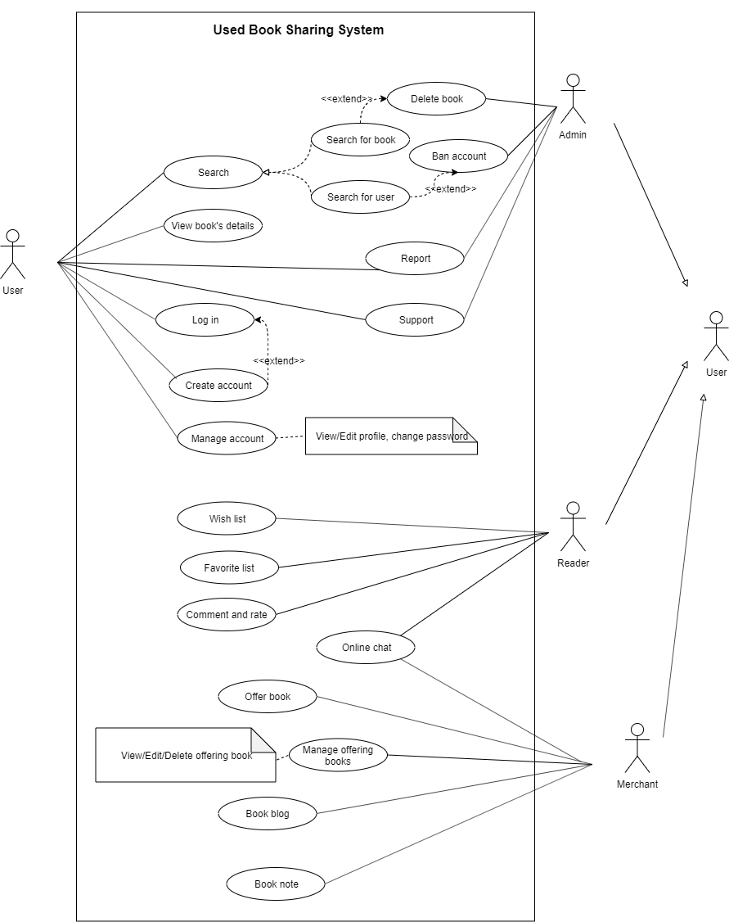

## 

# Logical View

(you can also see this component diagram at ‘images/ComponentDiagram.png’)

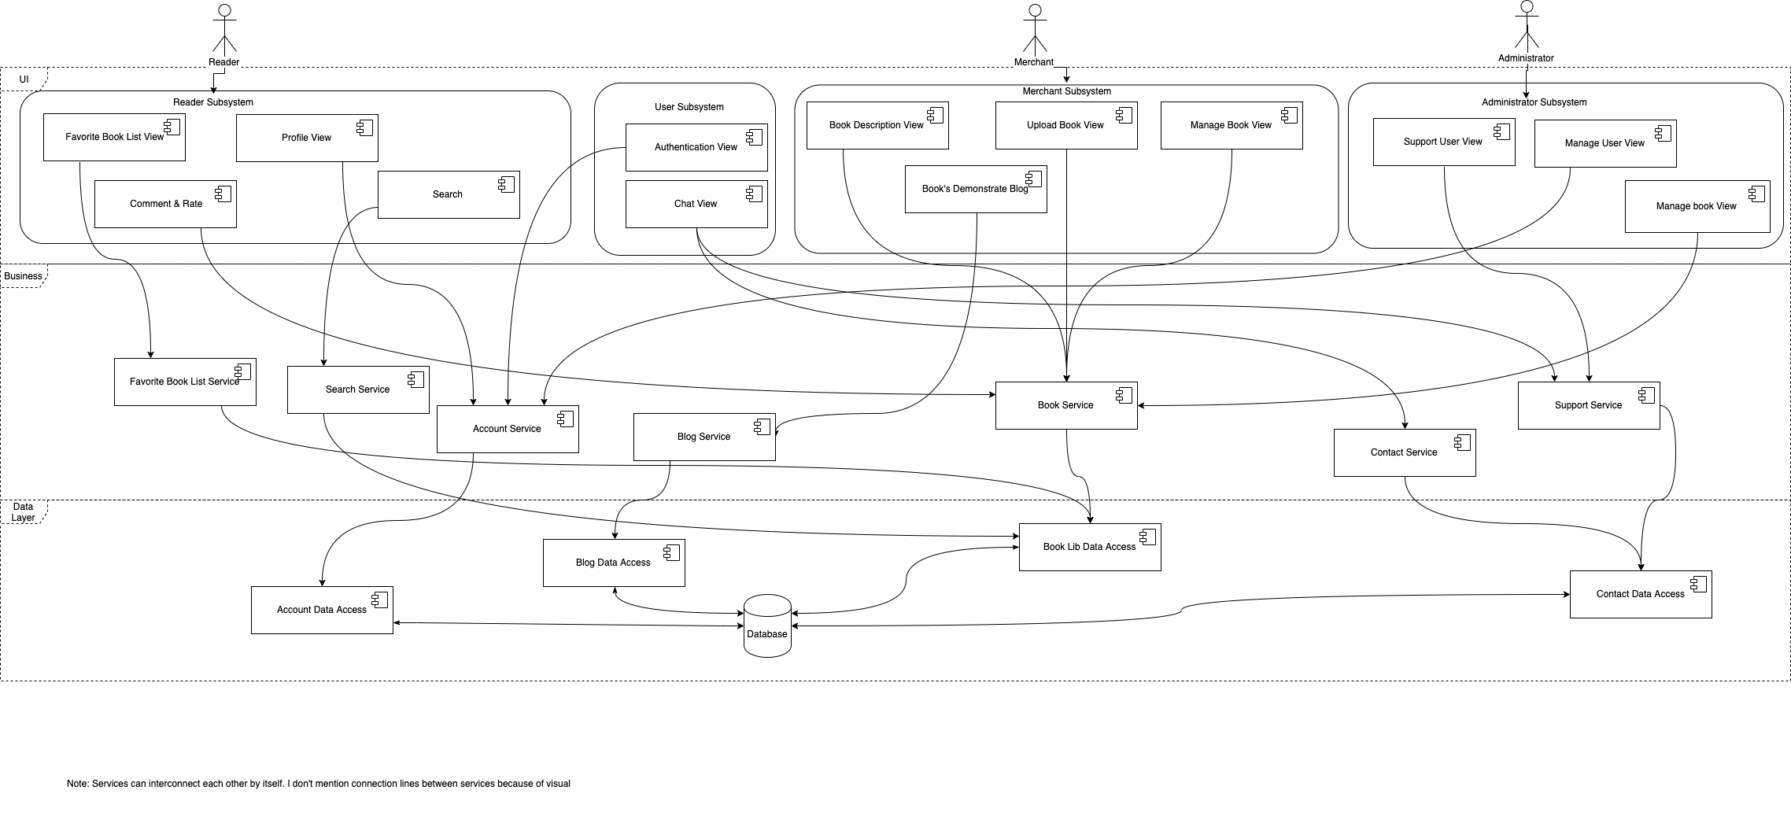

## Component: Favorite Book List View

* Description: Component use to display for user about his/her favorite book list.

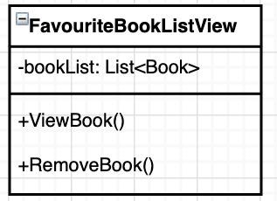

## Component: Search View

* Description: Component use to display for user can search book with some option.

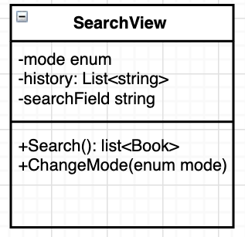

## Component: Comment & Rate View

* Description: Component use to display for user comment and rating for book or merchant.

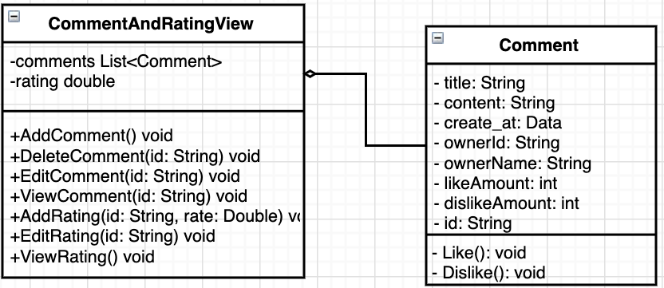

## Component: Profile View

* Description: Component use to display user’s profile.

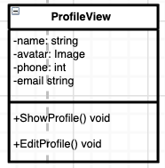

## Component: Book Service

* Description: Provide service for any function have using book.

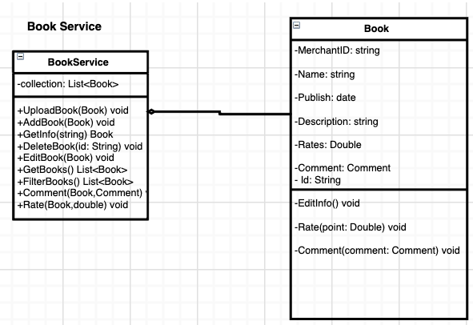

## Component: Account Service

* Description: Provide service for any function have using user information.

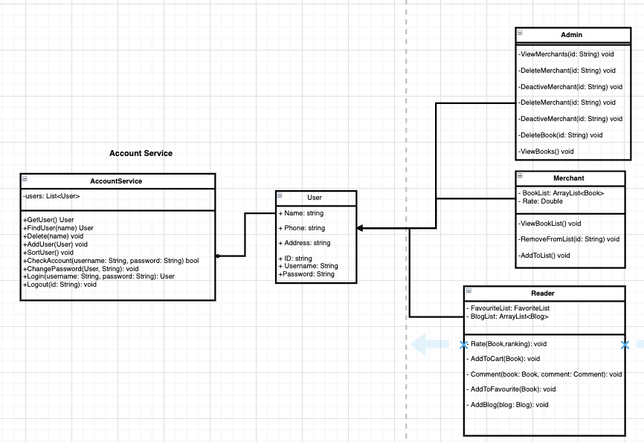

## Component: Search Service

* Description: Provide service for any function have using search engine.

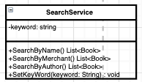

## Component: Book Demonstrate Blog View

* Description: UI display for merchant can write blog to demonstrate about book.

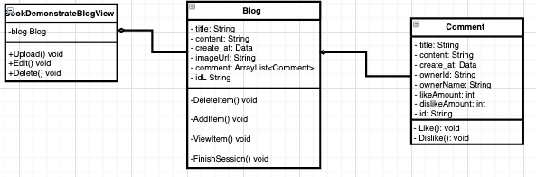

## Component: Blog Service

* Description: Provide service for any function using blog.

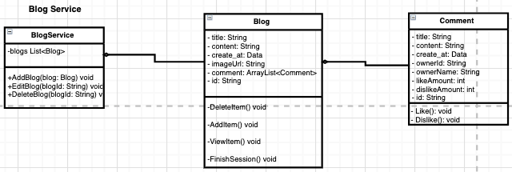

## Component: Contact Service

* Description: Provide service for any function using contact.

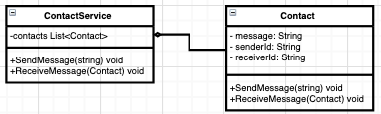

## Component: Book Description View

* Description: display information about book for reader can read.

## 

## Component: Chat View

* Description: Display UI for reader/ merchant can chat with each other or report error for administrator.

## 

## Component: Authentication View

* Description: Display UI for user can verify user’s account before user can use this account.

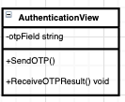

## Component: Support User View

* Description: Display UI for administrator can manage error, fix and update error status.

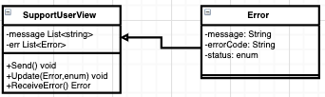

## Component: Upload Book View

* Description: Display UI for merchant update book into website.

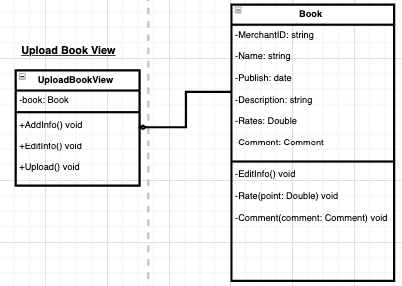

## Component:Manage Book View

* Description: Provide UI for merchant can manage their uploaded book.

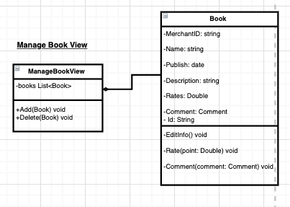

## Component: Support Service

* Description: Notification error when user report for administrator and update status of error into system to manage.

## 

## Component: Favorite Book List Service

* Description: Provide UI for reader can manage their favorite book list.

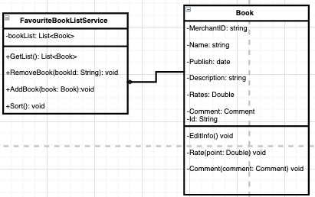

## Component: Contact Data Access

* Description: Connect to database to get or edit data about contact.

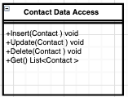

## Component: Book Library Data Access

* Description: Connect to database to get or edit data about book.

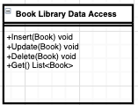

## Component: Account Data Access

* Description: Connect to database to get or edit data about account.

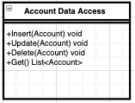

## Component: Blog Data Access

* Description: Connect to database to get or edit data about blog.

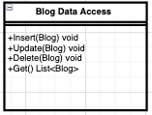

## Component: Manage User View

* Description: Provide UI for administrator can manage reader/merchant account to prevent illegal action immediately.

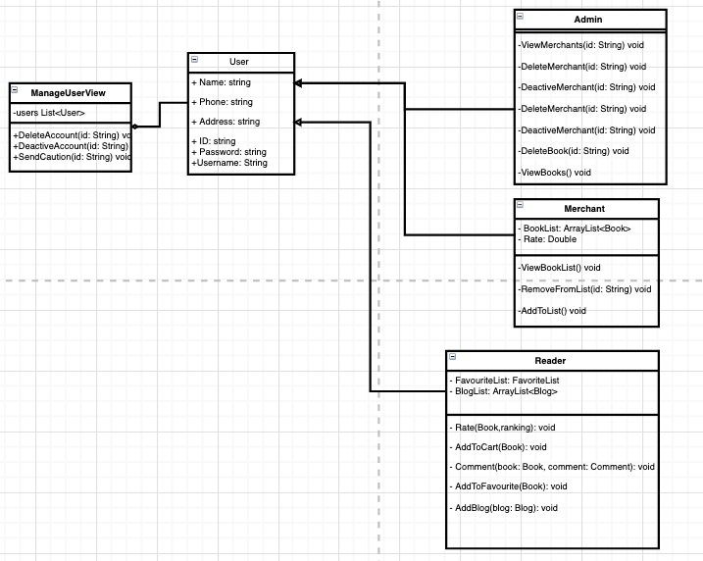

# Deployment

*[Leave this section blank for PA3.]*

# Implementation View

*[Leave this section blank for PA3.]*